Accelerated growth of the coral Orbicella faveolata in the turbid and polluted waters of Varadero Reef, Colombian Caribbean

Luis Lizcano-Sandoval^{a,b,c}, Angela Marulanda-Gómez^{x}, Alberto Rodriguez-Ramirez^{x}, Mateo López-Victoria^{x}

ªPosgrado de Ciencias del Mar y Limnología, Universidad Nacional Autónoma de México, Puerto Morelos, Mexico
^{b}College of Marine Science, University of South Florida, St. Petersburg, FL, USA
^{c}Environmental Mapping Team, Spatial Informatics Group, Pleasanton, CA, USA
^{x}[Insert affiliations]

Abstract
[To be Completed]
Keywords: coral growth, linear extension, sediments, Cartagena Bay, Canal del Dique
Introduction
Coral reefs are increasingly threatened by rising temperatures, diseases, pollution, eutrophication, acidification, among others impacts that jeopardize their stability and persistence (Sully et al. 2019; Guan et al. 2020; Davis et al. 2021; Burke et al. 2023). Typically, “healthy” reefs thrive in tropical and oligotrophic waters, ranging from shallow to mesophotic depths (Kahng et al. 2010; Guan et al. 2015). However, water quality has been declining over time due to intensified human impacts on oceans and coastal areas (Halpern et al. 2019). Under turbid conditions, corals may find refugia from thermal stress (Sully and van Woesik 2020), shift from autotrophy to heterotrophy (Anthony and Fabricius 2000; Travaglione et al. 2023), reduce lipid content (Jones et al. 2020), photoacclimate to low light exposure (Jones et al. 2020; López-Londoño et al. 2021), and increase number of pigments per cell (Jones et al. 2020), though they also face risks of bleaching and mortality (Fisher et al. 2019). Approximately 12% of the world’s coral reefs are found in moderately turbid waters (0.080-0.127 K_{d}490) (Sully and van Woesik 2020). However, anthropogenic development has increased the exposition of coral reefs to higher levels of turbidity and pollution (Zweifler et al. 2021). Despite these challenges, evidence shows that some coral reefs survive under highly turbid conditions (Camp et al. 2018; Burt et al. 2020; Zweifler et al. 2021). The coral reef facing the most extreme turbidity in the Caribbean is Varadero Reef, Colombia (Fig. 1) (López-Victoria et al. 2015; Zweifler et al. 2021). This well-developed reef exhibits typical signs of a healthy ecosystem, including high coral diversity, 45% coral cover, and large colonies of the coral Orbicella faveolata (López-Victoria et al. 2015; Pizarro et al. 2017). Varadero Reef exists in a light-limited environment, influenced by freshwater discharge and industrial wastewater flowing into Cartagena Bay (Fig. 1).
Water quality in Cartagena Bay is highly variable both in seasonal and spatial scales (Tosic et al. 2019) (Fig. 2). Several parameters exceed threshold values that are not optimal for biotic health or sustaining life. Elevated concentrations of heavy metals, such as cadmium, lead, mercury, chromium, copper, nickel have been found in the water (Tosic et al. 2019), sediments (Cogua et al. 2012), and organisms (Alonso et al. 2000; Manjarrez et al. 2008). Cartagena Bay’s waters experience seasonal increases in nutrient levels and decreases in dissolved oxygen, occasionally reaching hypoxic conditions (Tuchkovenko and Lonin 2003; Tosic et al. 2019). Organic matter and high coliform counts have also been observed (Garay and Giraldo 1997; Tuchkovenko and Rendón 2002; Tosic et al. 2019). Domestic sewage and industrial wastewaters contribute pollutants to the bay, but it is the Canal del Dique that has caused significant declines in water quality (Tosic et al. 2018).
The Canal del Dique connects the Magdalena River and Cartagena Bay since 1934, and it is a navigable channel of 115 km length (Mogollón 2002, 2013) (Fig. 1). It was fully channelized between 1950 and 1952, leading to the transformation of Cartagena Bay’s clear waters into turbid waters due to freshwater discharge (Mogollón 2013). Between 1981 and 1984, the Canal del Dique was rectified and expanded in both depth and width. During this period, nearly 47% of the soil and sediments dredged throughout the 20th century were removed (Mogollón 2013). Annual maintenance is required to remove accumulated sediments, a practice that continues today. Between 1984 and 2010, the Canal del Dique increased water discharge by 28% and sediment load by 48%, contributing approximately 52 Mt of sediment to Cartagena Bay (Restrepo et al. 2018). While sedimentary evidence suggests that Cartagena Bay had a significant presence of scleractinian corals and seagrasses during the late Holocene (Martínez et al. 2010), but changes in water quality have adversely affected these ecosystems. Seagrass cover in the bay declined by about 92% between 1935 and 2001 (Díaz and Gómez 2003), with no recent data available. Coral reefs here were once thought to be nonexistent, until recent studies (López-Victoria et al. 2015).

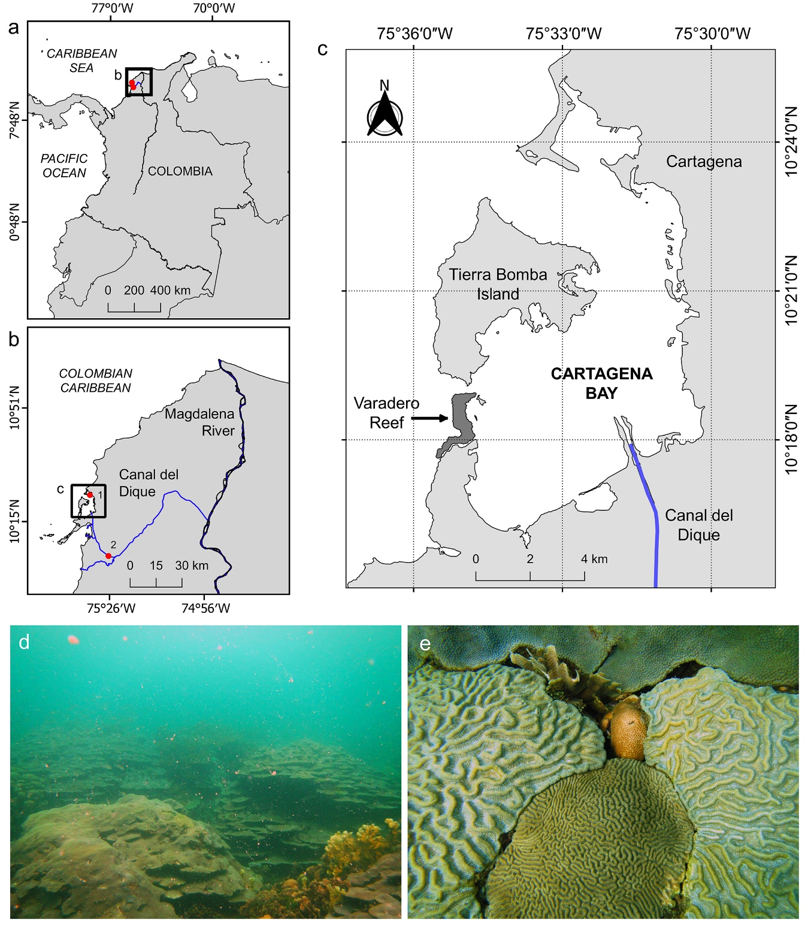
Figure 1. Geographic location of the Varadero coral reef. (a-b) The connection between the Canal del Dique and the Magdalena River, and (c) location of Varadero reef within Cartagena Bay. Hydrological and metereological stations are indicated by red dots in panel b: 1. Naval station, and 2. Santa Helena 2 station. (d) Orbicella faveolata colonies growing in plate-like forms at 4 m depth, along with the presence of marine snow. (e) Corals compiting for substrate in less than 1 m²: Colpophyllia natans, Pseudodiploria clivosa, Agaricia tenuifolia, Siderastrea siderea and O. faveolata.

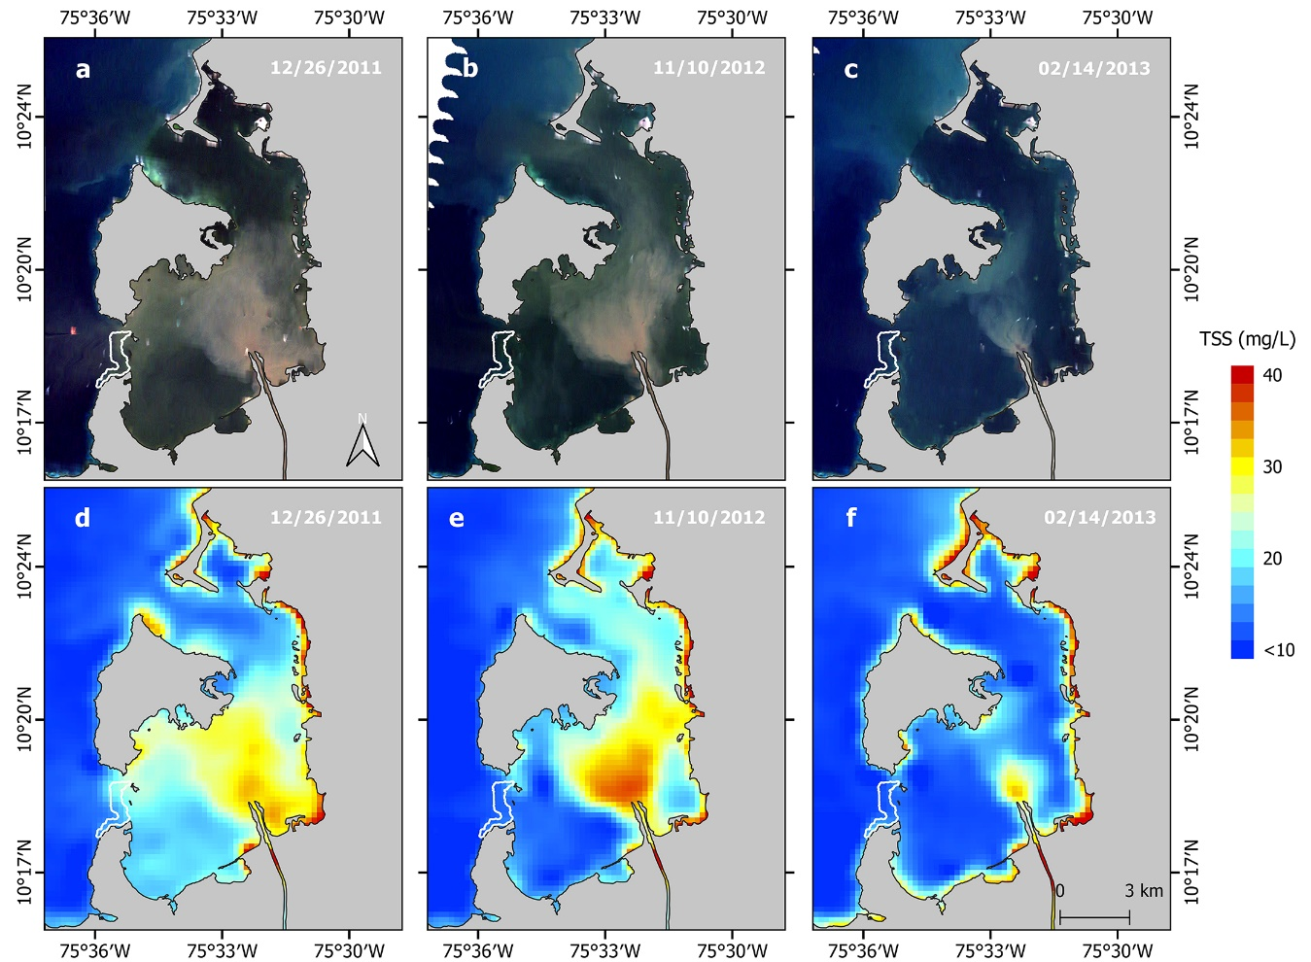
Figure 2. Total suspended sediments (TSS) within Cartagena Bay according to three water flow rates recorded upstream the Canal del Dique (Santa Helena Station): high (632 m³ s⁻¹) on December 26, 2011, moderate (378 m³ s⁻¹) on November 10, 2012, and low (158 m³ s⁻¹) on February 14, 2013. True-color satellite imagery showing different levels of suspended sediments in Cartagena Bay (a-c). MODIS Terra (MOD09GQ; band 1) satellite imagery calibrated for TSS following the model by Restrepo et al. (2016) (d-f). The Varadero coral reef is outlined by a white-bordered polygon.

Evaluating the resistance and recovery of coral reefs over disturbances and local environmental conditions is critical for developing effective conservation strategies (McClanahan et al. 2012). Massive corals respond to environmental changes by modulating their calcification rates and skeletal microstructure, recording these variations in their skeleton (Barnes and Lough 1993; Carricart-Ganivet 2004; Dávalos-Dehullu et al. 2008). In corals of the genus Orbicella, seasonal temperature variations are recorded as changes in skeletal density bands, with low-density bands corresponding to cooler seasons and high-density bands indicating warmer seasons (Hudson et al. 1976; Carricart-Ganivet 2011). Each pair of bands represent one year of coral growth. Changes in skeletal luminescence also serve as a proxy for humic acid and sediment concentrations in the water (Grove et al. 2010; Tanzil et al. 2016). The ability of coral skeletons to record environmental responses provides an opportunity to track coral growth and reconstruct potential past disturbances. In this study, we measured coral growth parameters, including skeletal density, linear extension, calcification rates, and skeletal luminescence, in Orbicella faveolata to assess the effects of environmental changes and perturbations in Cartagena Bay on coral growth. We specifically analyzed the impacts of the Canal del Dique dredging between 1981 and 1984.

Material and methods
Study area
The Varadero coral reef is located within Cartagena Bay, Colombian Caribbean (Fig. 1). Covering an area of approximately 1 km², the reef presents up to 80% live coral cover, dominated by massive colonies of O. faveolata that can exceed 3 m in diameter (López-Victoria et al. 2015; Pizarro et al. 2017). Several coral species are observed growing in this environment competing for space (Fig. 1e).
This coral reef is influenced by the turbid and polluted waters from the Canal del Dique, an extension of the Magdalena River (Fig. 1d, Fig. 2). The region experiences climate patterns that influence water quality in the bay. During the rainy season (September to December), salinity decreases while suspended particles and nutrient concentrations increase. In the windy season (January to April), water temperature decreases, and organic matter levels are high. During the transitional season (May to August), water temperature rises, and dissolved oxygen decrease (Tosic et al. 2019). Air temperatures are cooler from October to April and warmer from May to September (Fig. 3).
Coral core sampling
A single core of 6 cm diameter was extracted along the growth axis from four massive O. faveolata colonies at 3-4 m depth using a pneumatic drill. The affected area on the donor colony (25-30 cm²) was covered with a polystyrene ball and epoxy putty to prevent the intrusion of bioeroder organisms. The coral cores were transported to the laboratory.

Figure 3. Climatology of hydrological and environmental data for the Canal del Dique and Cartagena Bay (1950-2015). The data sources are detailed in the methods section.

Coral growth analysis
One of the coral cores (VAR1) was sliced into several slabs of 6 mm thick prior to using the CT-scan method for coral density estimation. One of these slabs was selected to be radiographed using a conventional X-ray machine, and coral density was estimated according to Carricart-Ganivet and Barnes (2007). Radiation effects on the radiograph were corrected following Duprey (2012). The remaining three coral cores (VAR2, VAR3, VAR4) were imaged using a General Electric LightSpeed VCT 64 CT-scan as described by (Lizcano-Sandoval et al. 2019). The skeletal density of all four coral specimens was calibrated using aragonite density standards obtained from the shell of the giant clam Tridacna maxima (Lizcano-Sandoval et al. 2019).
For scanned coral cores, the best planes for observing the density banding pattern were selected by inspecting multi-planar reconstructions. For each core, one sagittal and one coronal image were chosen, and a single transect was drawn along the coral growth axis in each image to extract optical density values in Hounsfield units (HU). The HU values from both transects were averaged for each core. These averaged HU values were then converted to skeletal density (Lizcano-Sandoval et al. 2019). The CT-scan images were visualized and analyzed using RadiAnt DICOM Viewer 4.0.
The annual skeletal density pattern (Fig. 4) for orbicellid corals is characterized by a high-density band formed during the warm season and a low-density band formed during the cold season (Carricart-Ganivet et al. 2000; Carricart-Ganivet 2004). The highest and lowest density peaks along the coral skeleton of the collected specimens corresponded to late June and February, respectively, consistent with the climatology of Cartagena Bay (Fig. 3). For both CT-scan and X-ray images, coral years were counted retrospectively. Skeletal density (g cm⁻³), linear extension (cm yr⁻¹) and calcification rates (g cm⁻² yr⁻¹) were estimated annually. Linear extension was calculated from early January to late December of each year, while calcification was determined as the product of skeletal density and linear extension.

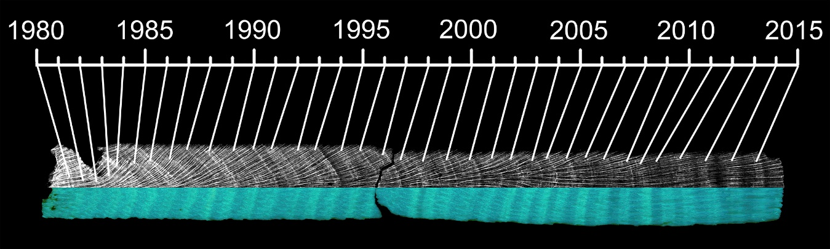
Figure 4. Coral growth band patterns along an O. faveolate core. The annual skeletal density is shown in grayscale (X-ray) as dark (low density) and light (high density) bands. Annual luminescent bands, visible under UV-A light, show bands of high and low intensity.

Since the aragonite standards used for estimating coral skeletal density in both X-ray and CT-scan methods were the same, we included X-ray derived coral density in the global coral growth analysis, assuming minimal error between both methods. The mean skeletal density of core VAR1 (0.69 ± 0.09 g cm⁻² yr⁻¹) fell within the range of the densities measured for cores VAR2, VAR3 and VAR4 over the period of 1981-2015 (min: 0.65 ± 0.09 g cm⁻² yr⁻¹ and max: 0.77 ± 0.12 g cm⁻² yr⁻¹), suggesting that density estimates were comparable between the two methods.
Additional measurements were taken on the exothecal dissepiments randomly along the coral slabs, including the number of annual dissepiments, their thickness, and spacing (Dodge et al. 1992; Dávalos-Dehullu et al. 2008). The continuous measurement of the number of dissepiments per year was challenging due to changes in the trajectory of the exothecas. Forty measurements of dissepiment thickness and spacing were taken for each coral specimen.
Coral luminescence analysis
All coral cores were cut into slabs of 6 mm thick and treated with 13% reagent-grade NaOCl for 24 h (Nagtegaal et al. 2012). After treatment, the slabs were rinsed several times with distilled water and oven-dried at 60°C for 24 h. Annual luminescence patterns on the coral cores were visualized and photographed under UV-A light (Opalux blacklight bulb T8 20W) in a black box (Fig. 4). The red, green and blue (RGB) values were extracted from 5 mm wide tracks (62 pixels) along the coral growth axis for each digital photograph using ImageJ 1.51. The green/blue (G/B) ratio was then used as a measure of luminescence intensity. The G/B ratio reflects the influence of humic acid/aragonite ratios within the coral skeleton (Grove et al. 2010), with higher G/B intensities indicating higher freshwater discharge and sediment load (Tanzil et al. 2016). Consequently, the highest and lowest annual luminescence peaks were aligned with the months of highest (late December) and lowest (late March) water flow records, respectively (Fig. 3).
Hydrological and environmental data
Monthly water flow data (1981‒2015) from the Canal del Dique at the Santa Helena station (ID 29037450) (Fig. 1b) were obtained from the Instituto de Hidrologia, Metereologia y Estudios Ambientales (IDEAM). Monthly air temperature data (1954‒2013) were obtained from the IDEAM’s Escuela Naval station (ID 14015030) (Fig. 1b). To complete the time series, data for the period 2014-2016 were extrapolated by modeling air temperature using data from the Rafael Nuñez Airport station (ID 14015080), located 6 km north of the Escuela Naval station.
The Southern Oscillation Index (SOI) data were obtained from the National Oceanic and Atmospheric Administration (NOAA) (https://www.ncdc.noaa.gov/teleconnections/enso/indicators/soi/). Negative and positive values of this index indicate El Niño and La Niña events, respectively. The Atlantic Multidecadal Oscillation (AMO) data were sourced from the Kaplan SST dataset (Enfield et al. 2001). The AMO is an index of North Atlantic temperatures that influences the growth of O. faveolata (Lizcano-Sandoval et al. 2019). Both SOI and AMO data were downloaded for the period of 1954-2015 to align with the temperature data.
Data treatment and analyses
Time series were obtained for skeletal density, linear extension, calcification and luminescence. Mean values for each coral growth variable (i.e., master chronologies) were calculated from at least two measurements per year (i.e., from two cores). Person correlations were performed between skeletal density, linear extension, and calcification rates. Linear regressions were used to detect trends over the time series of coral growth, coral luminescence, and environmental data. Change point detection analysis was conducted to identify statistical changes between segments or states within the time series (Aminikhanghahi and Cook 2017; Truong et al. 2020). We employed the PELT algorithm for point change detection, which has been demonstrated to be efficient and accurate compared to other methods (Killick et al. 2012). Additionally, we compared the mean values of coral growth variables and skeletal luminescence between periods before and after the major dredging events that began in 1981, using a two-tailed t-test assuming unequal variances and an alpha level of 0.05.
The effects of environmental variables on coral growth and skeletal luminescence were tested for two periods: 1954-2015 and 1981-2015. The period 1981-2015 included water flow data, which became available after 1981, coinciding with major dredging events of the Canal del Dique. A model selection procedure was conducted to identify the best-performing predictor variables for use in a multiple linear regression, using the Akaike Information Criterion with a stepwise selection approach (Quinn and Keough 2002). However, the model selection did not identify more than one predictor variable to justify running a multiple linear regression (See Supplementary Information). As a result, simple linear regressions were performed. If none of the predictor variables outperformed a null model, the analysis was omitted. The response variables were centered, and predictors transformed into z-scores to standardize the data before performing the regressions, resulting in intercepts of zero. The model selection was conducted using the Fathom package in Matlab vR2022a, while plots and additional analyses were completed using Python. The point change detection analysis utilzed the ruptures Python package (Truong et al. 2020).

Results
Coral growth
The mean and standard deviation values of the skeletal density, linear extension and calcification were 0.72 ± 0.07 g cm⁻³, 1.03 ± 0.13 cm yr⁻¹ and 0.74 ± 0.10 g cm⁻² yr⁻¹, respectively, corresponding to the period 1951-2015 (Table 1). The linear extension was negatively correlated to skeletal density (r = -0.29; p = 0.02; Pearson) and positively correlated to calcification rates (r = 0.69; p < 0.01; Pearson). The skeletal density was positively correlated to calcification (r = 0.46, p < 0.01; Pearson). The mean number of dissepiments per year along the coral slabs was 21.3 ± 1.3, while dissepiment thickness and spacing were 0.13 ± 0.01 mm and 0.57 ± 0.06 mm, respectively.

Table 1. Coral growth mean and standard deviations from four cores of the coral O. faveolata in Varadero Reef.
Specimen | Time span | n | Density  (g cm⁻³) | Extension  (cm yr⁻¹) | Calcification  (g cm⁻² yr⁻¹)
VAR1 | 1982-2015 | 34 | 0.69 ± 0.08 | 1.33 ± 0.35 | 0.91 ± 0.24
VAR2 | 1951-2015 | 65 | 0.73 ± 0.14 | 1.04 ± 0.20 | 0.77 ± 0.22
VAR3 | 1942-2015 | 74 | 0.80 ± 0.12 | 0.91 ± 0.22 | 0.74 ± 0.23
VAR4 | 1950-2015 | 66 | 0.67 ± 0.13 | 1.02 ± 0.20 | 0.67 ± 0.15
Mean | 1951-2015 | 65 | 0.73 ± 0.07 | 1.02 ± 0.13 | 0.74 ± 0.10

Table 2. Linear regression results of mean coral growth and coral luminescence, and environmental time series data. The slopes are significant different from zero at p < 0.05.
Variable | Period | n | Intercept | Slope | R² | F | p
Density | 1951-2015 | 65 | 4.31 | -0.002 | 0.22 | 18 | < 0.01
Extension | 1951-2015 | 65 | -1.22 | 0.001 | 0.03 | 1.7 | 0.20
Calcification | 1951-2015 | 65 | 3.48 | -0.001 | 0.06 | 4.3 | 0.04
Luminescence | 1951-2015 | 65 | 2.21 | -0.001 | 0.45 | 52 | < 0.01
Water flow | 1981-2015 | 35 | -8115 | 4.240 | 0.20 | 8 | < 0.01
Temperature | 1953-2015 | 63 | 20.37 | 0.004 | 0.04 | 2.8 | 0.10
AMO | 1953-2015 | 63 | -6.10 | 0.003 | 0.09 | 6 | 0.02
SOI | 1953-2015 | 63 | 5.41 | -0.003 | 0.01 | 0.4 | 0.53

Skeletal density, calcification rate, and skeletal luminescence showed significant declines between 1951 and 2015 (Table 2; Fig. 5). Significant increases in water from 1981 to 2015 and in the AMO from 1951 to 2015 were detected (Table 2; Fig. 5). Point changes detected in 1982 for skeletal density; in 1966 and 1986 for linear extension; in 1961 for calcification rate; and in 1956, 1996, 2001, and 2011 for skeletal luminescence (Fig. 5). After 1986, linear extension exhibited greater variability among coral cores (Fig. 5). Some points of change in temperature, SOI and AMO time series occurred concurrently between 1971 and 1976 (Fig. 5), a period characterized by a low peak in air temperature and AMO, and a high peak in SOI. Both SOI and AMO showed apparent increasing trends after 1996, while temperature data showed a shift in 2001, as indicated by the point change detection. Water flow data also depicted an increase in flow between 2006 and 2011 (Fig. 5).
The mean values for skeletal density and skeletal luminescence during the period 1951-1981 were statistically higher than those observed from 1981-2015 (t-test: p < 0.001) (Fig. 6). The mean values for linear extension were higher (t-test: p = 0.049), and calcification rates were lower (t-test: p = 0.131), during 1981-2015 compared to the period 1951-1981 (Fig. 6).

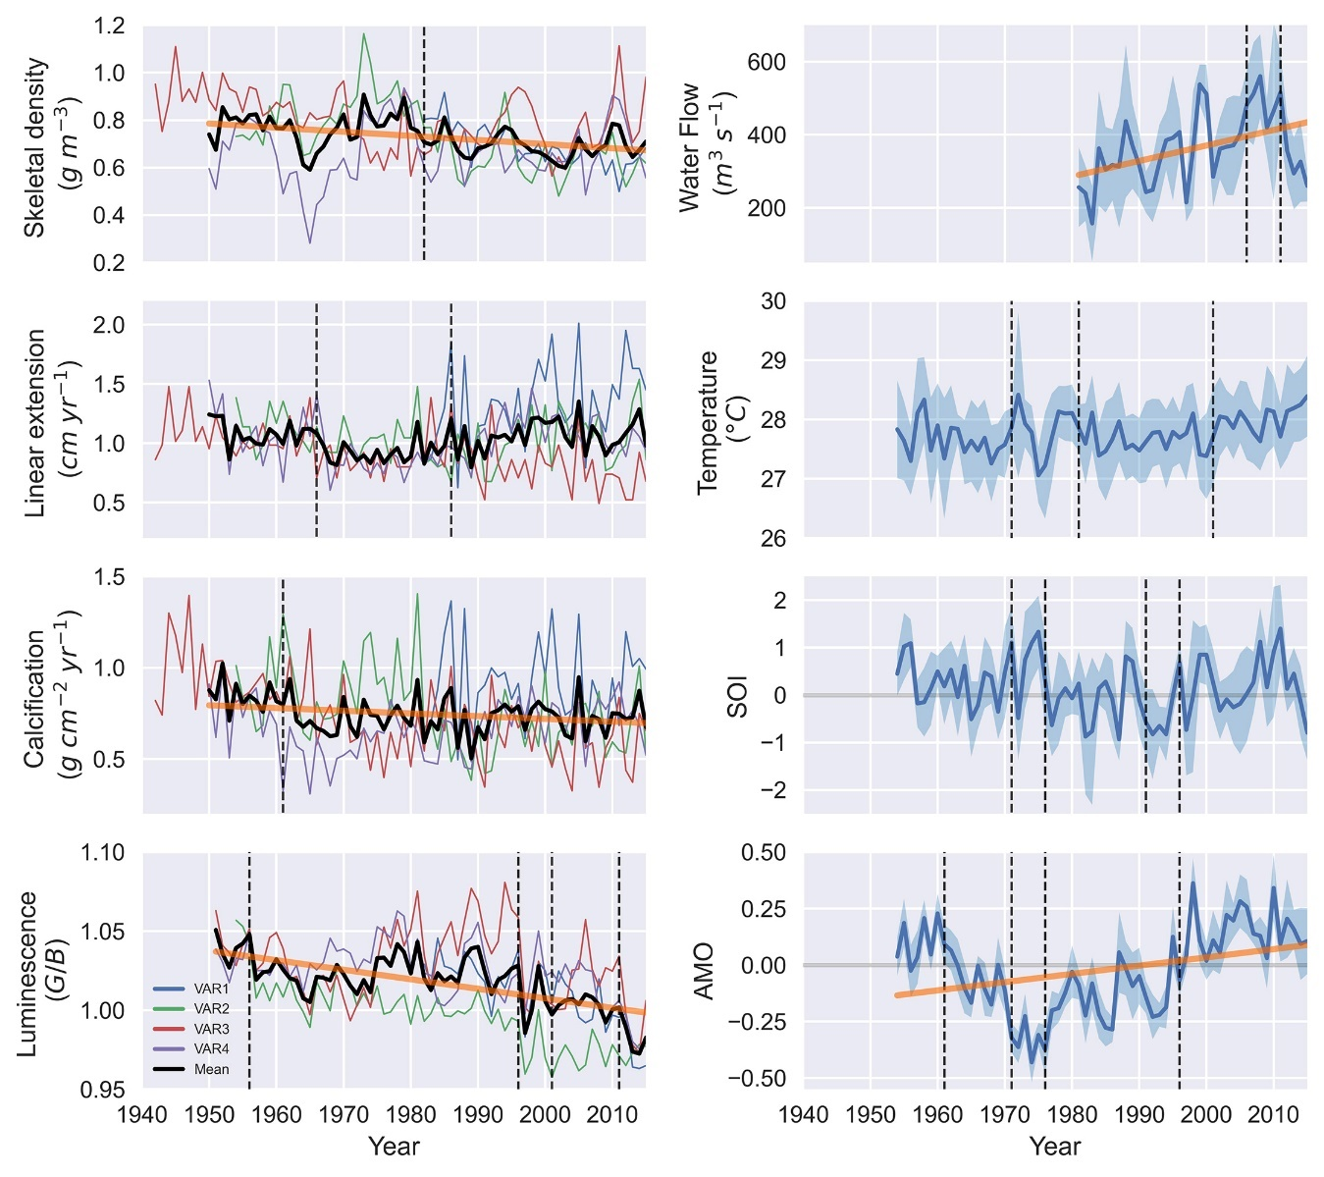
Figure 5. Time series of coral growth, coral luminescence, and environmental data (shaded area indicates annual standard deviations). The legend of coral cores corresponds to the left subplots. Significant trends over time are indicated by bold orange lines indicate (linear regression: p < 0.05). Vertical dashed lines mark points of change in the time series.

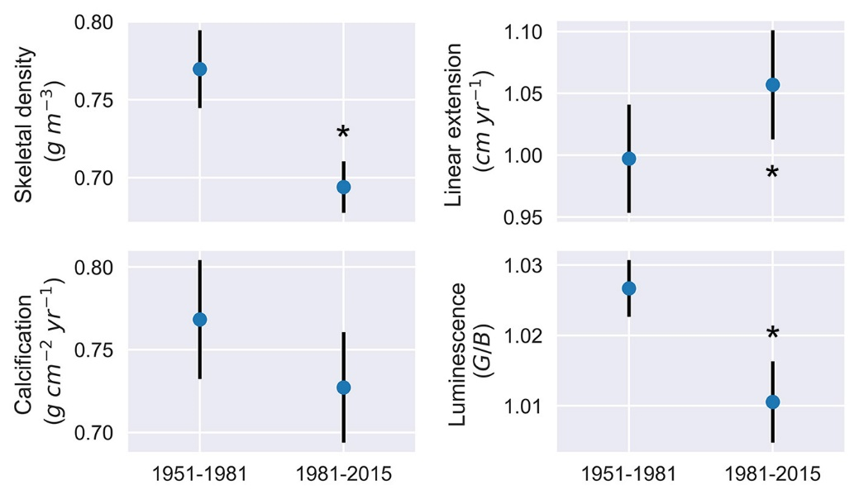
Figure 6. Coral growth and skeletal luminescence (mean ± CI 95%) before and after the major dredging of 1981 in the Canal del Dique. The asterisks indicate significant differences of respective variables between the two periods (t-test: p < 0.05).

The model selection procedure indicated that predictors variables such as AMO, SOI, Temperature were the most adequate for linear regression analysis in both periods 1954-2015 and 1981-2015 (Supplementary Information). The AMO explained 8% of the decrease and 19% of the increase in skeletal density and linear extension over 1954-2015, respectively (Table 3). Air temperature explained 22% of the decrease in luminescence over the same period. Over 1981-2015, the temperature significantly explained 45% of the decrease in luminescence (Table 4).

Table 3. Linear regression results for annual coral growth and luminescence variables against environmental predictors for the period 1954-2015. All regressions have intercept set to zero. Significant slopes are identified with a p-value of < 0.05.
Variable/Predictor | Slope | R² | p-value
Density
AMO | -0.11 | 0.08 | 0.025
Extension
AMO | 0.30 | 0.19 | 0.001
Calcification
SOI | 0.04 | 0.06 | 0.069
Luminescence
Temperature | -0.03 | 0.22 | 0.001

Table 4. Linear regression results for annual coral growth and luminescence variables against environmental predictors for the period 1981-2015. All regressions have intercept set to zero. Significant slopes are identified with a p-value of < 0.05.
Variable/Predictor | Slope | R² | p-value
Density
AMO | -0.32 | 0.10 | 0.061
Extension
AMO | 0.26 | 0.07 | 0.144
Luminescence
Temperature | -0.67 | 0.45 | 0.001

Discussion
Coral growth characteristics
The coral colonies of O. faveolata in Varadero Reef exhibit low skeletal density and calcification rates, while their linear extension remains relatively stable over time. The average skeletal density and calcification rates observed are the lowest reported for this species at 4 m depth, despite maintaining relatively high linear extension rates (Table 5). These corals grow under low-light conditions caused by high water turbidity, resulting in colony shapes typical of those found in light-limited environments (Pizarro et al. 2017; López-Londoño et al. 2021). The light availability and physiology of O. faveolata at 4 m depth in Varadero Reef are similar to those observed in O. faveolata colonies at 12 m depth in reefs of the Rosario Islands (Colombian Caribbean), where water quality is better (López-Londoño et al. 2021). In response to decreasing light availability with increasing depth, orbicellid corals typically increase skeletal density while reducing linear extension and calcification rates (Baker and Weber 1975; Dustan 1975; Bosscher 1993). However, the skeletal growth characteristics of O. faveolata in Varadero Reef deviate from expected patterns for corals growing under low-light conditions. Correlations between the growth variables suggest that the observed growth strategy of O. faveolata focuses on utilizing calcification products to achieve faster vertical growth with less dense skeletons, contrary to previous findings for orbicellid corals (Carricart-Ganivet and Merino 2001). The benefits of faster growth in the shallow suboptimal conditions of Varadero Reef (~2-6 m depth for O. faveolata) remain uncertain.

Table 5. Linear extension, skeletal density, and calcification rates of O. faveolata over relatively long periods and different depths in the Caribbean Sea.
Location | Period | Depth (m) | Number of cores | Extension (cm yr⁻¹) | Density  (g cm⁻³) | Calcification (g cm⁻² yr⁻¹) | Reference
Veracruz Reef, Mexico | 1835-2002 |  | 1 | 1.12 ± 0.23 |  |  | (Horta-Puga and Carriquiry 2014)
Upper Florida Keys, USA | 1937-1996 |  | 7 | 0.79 ± 0.07 | 1.18 ± 0.06 | 0.91 ± 0.06 | (Helmle et al. 2011)
Turneffe Islands, Belize | 1954-1996 | 2 | 1 | 0.88 ± 0.07 | 0.98 ± 0.05 | 0.83 ± 0.11 | (Zoppe and Gischler 2024)
Glovers Reef, Belize | 1899-2005 | 4 | 1 | 0.95 ± 0.09 | 1.13 ± 0.06 | 1.07 ± 0.11 | Zoppe and Gischler (2024)
Varadero Reef, Colombia | 1951-2015 | 4 | 4 | 1.02 ± 0.13 | 0.73 ± 0.07 | 0.74 ± 0.10 | This study
Cheeca Rocks Reef, USA | 2004-2013 | 4 - 5 | 11 | 0.89 ± 0.07 | 1.25 ± 0.03 | 1.10 ± 0.08 | (Manzello et al. 2015)
Barrier reef, Belize | 1942-1999 | 4.8 | 1 | 1.20 ± 0.01 | 0.99 ± 0.05 | 1.19 ± 0.10 | Zoppe and Gischler (2024)
Little Conch Reef, USA | 2004-2013 | 5 - 6 | 12 | 0.73 ± 0.03 | 1.34 ± 0.01 | 0.97 ± 0.03 | (Manzello et al. 2015)
Serrana Cay, Colombia | 1963-2015 | 4 - 9 | 5 | 0.96 ± 0.11 | 1.08 ± 0.08 | 1.02 ± 0.12 | (Lizcano-Sandoval et al. 2019)
Cayo Arenas, Mexico | 1992-2016 | 7 - 12 | 5 | 0.82 ± 0.08 | 1.04 ± 0.30 | 0.85 ± 0.18 | (Sánchez-Pelcastre et al. 2023)
Flower Garden Banks, USA | 1970-2014 | 19 | 10 | 0.71 ± 0.04 | 1.42 ± 0.03 | 0.99 ± 0.05 | (Manzello et al. 2021)

Skeletal microstructure characteristics
The mean number of dissepiments per year (21.3 ± 1.3) was nearly double that observed in other studies. O. faveolata specimens from Mahahual, Mexico and La Parguera, Puerto Rico recorded annual averages of 13.6 ± 0.9 (Dávalos-Dehullu et al. 2008) and 11.8 ± 1.6 (Winter and Sammarco 2010) exothecal dissepiments, respectively. The dissepiment spacing observed in this study (0.57 ± 0.06 mm) was similar to that found by Dávalos-Duhullu et al. (2008), but the dissepiments in Varadero were almost twice as thick (0.13 ± 0.01 mm). The low skeletal density observed can be also attributed to the high number of dissepiments formed annually. The decline in skeletal luminescence intensity after 1981 may be related to the decrease in skeletal density, as skeletal microstructure contributes a small proportion to luminescence (Barnes and Taylor 2005). However, the causes of variations in skeletal microstructure remain unclear. Some studies suggest that these variations are due to seasonal changes in tissue thickness and calcification rates, which affect coral density banding patterns (Barnes and Lough 1993; Cruz-Piñón et al. 2003; Dávalos-Dehullu et al. 2008).
Lunar cycles have been proposed as a trigger for dissepiment formation, with one dissepiment forming per full moon on average (~12 annually) (Dávalos-Dehullu et al. 2008; Winter and Sammarco 2010). Corals can respond to lunar cycles by detecting the blue portion of lunar irradiance (Gorbunov and Falkowski 2002), but in Varadero Reef, the optical properties of the water are variable and suboptimal, particularly in the blue light spectrum (López-Londoño et al. 2021). If irradiance at 4 m depth in Varadero Reef represent between 20% and 30% of surface irradiance (Pizarro et al. 2017; López-Londoño et al. 2021), then moon light irradiance may range between 6 x 10⁻⁴ and 9 x 10⁻⁴ µmol quanta m⁻² s⁻¹, assuming zenith moon light irradiance at the surface is ~3 x 10⁻³ µmol quanta m⁻² s⁻¹ (Winter and Sammarco 2010). This hypothetical moon light irradiance at 4 m depth is below the coral photoreception sensitivity threshold of ~2 x 10⁻³ µmol quanta m⁻² s⁻¹ (Gorbunov and Falkowski 2002). However, daily variations in water quality can cause large fluctuations in light attenuation coefficients (K_{d}) in Varadero Reef (López-Londoño et al. 2021), which may temporarily enable corals to respond to light. The causes of variation in skeletal microstructure for O. faveolata in Varadero Reef remain unclear and are likely multifaceted. Further investigation into the effects of light on coral skeletal microstructure is needed.
Growth responses to environmental variables
The AMO accounted for 8% of the decreases in skeletal density and 20% of the increases in linear extension over the period 1954-2015. The growth of O. faveolata has shown to be related to the AMO to some extent, though the patterns may vary. Our results are comparable to those from the remote reefs of Serrana Cay, Colombian Caribbean, where AMO showed long-term influence in the skeletal growth of O. faveolata¸ as observed in Varadero Reef (Lizcano-Sandoval et al. 2019). However, contrasting patterns were found in O. faveolata corals from Belize and Florida, where linear extension and skeletal density were negatively and positively correlated to the AMO, respectively (Helmle et al. 2011; Zoppe and Gischler 2024). Temperature explained 22% of the decreases in skeletal luminescence in 1954-2015 and 45% in the period 1981-2015. Although no significant relationship was observed between changes in water flow and coral growth or luminescence variables after 1981, the time series change points for skeletal density and linear extension were detected in 1982 and 1986, respectively. The mean values of skeletal density, linear extension, and luminescence in the period 1981-2015 were significantly different from those of the period 1951-1981, suggesting a likely response to increased water flow and decreased water quality due to dredging activities from 1981 to 1984, which removed 18.8 million m³ of soil and sediments (Mogollón 2013). Additionally, skeletal luminescence showed an apparent response to El Niño from 1997-1998 and La Niña from 1998-2001, which coincided with low and high-water flow during those periods, respectively. The temperature data showed a decreased in temperature that coincided with La Niña from 1973-1976 and some slight increases in skeletal density and luminescence, and decreases in linear extension.
The corals in Varadero Reef are exposed to multiple stressors than can affect their skeletal density, linear extension, and calcification rates. Limited photosynthetic potential, combined with the presence of organic matter in the water column, can drive a shift towards increased heterotrophy to meet energetic requirements. For some tropical corals, heterotrophy can contribute 15% to 35% of daily energy requirements (Houlbrèque and Ferrier‐Pagès 2009). Under heterotrophic conditions, linear extension may double, skeletal density can decrease, and skeletal mass may increase (Ferrier-Pagès et al. 2003; Fabricius 2005). Cartagena Bay also experiences seasonal hypoxic conditions, with low dissolved oxygen levels (< 4 mg L⁻¹) occurring between 10 and 20 m depth, but during transitional seasons (May-August), these levels can be found at 5-10 m depth (Tosic et al. 2019). Prolonged exposure to hypoxia can lead to coral bleaching, tissue loss, or reduction in calcification rates (Pezner et al. 2023). Additionally, heavy metal concentrations (e.g., As, Zn, Cu, Ni, Cr, Mn, Fe, Pb) in Cartagena Bay often exceed acceptable standards (Restrepo et al. 2016; Tosic et al. 2019). Concentrations of total suspended solids (6-72 mg L⁻¹), nitrates (5-389 µg L⁻¹), and phosphates (17-140 µg L⁻¹) can also surpass thresholds considered healthy for coral ecosystems (Fabricius 2005; Tosic et al. 2019). A potential threat for coral growth in Varadero Reef that may require more attention is sea-level rise. Cartagena presents one of the largest sea-level rise rates in the Caribbean, which have accelerated between 2000 and 2019 with a rate of 7.02 mm yr⁻¹ (Restrepo-Ángel et al. 2021).
The absence of signs of mortality in any of the coral cores raises the question of how these corals have survived and apparently thrived for over 65 years under the influence of the Canal del Dique. However, the constant increase in water flow suggests a decline in water quality, which poses an ongoing threat to coral health and survival in Varadero Reef. The reason for an accelerated linear extension is unclear, but further research is required to understand coral growth and responses to the environmental conditions of Cartagena Bay. A more frequent and comprehensive water quality monitoring program is needed to assess the effects of the multiple stressors on coral growth, and conservation efforts should be implemented in the bay to protect Varadero Reef.

References
Alonso D, Pineda P, Olivero J, González H, Campos N (2000) Mercury levels in muscle of two fish species and sediments from the Cartagena Bay and the Cienaga Grande de Santa Marta, Colombia. Environmental Pollution 109:157–163
Aminikhanghahi S, Cook DJ (2017) A survey of methods for time series change point detection. Knowl Inf Syst 51:339–367
Anthony KRN, Fabricius KE (2000) Shifting roles of heterotrophy and autotrophy in coral energetics under varying turbidity. J Exp Mar Biol Ecol 252:221–253
Baker PA, Weber JN (1975) Coral growth rate: Variation with depth. Earth and Planetary Science Letters 27:57–61
Barnes DJ, Lough JM (1993) On the nature and causes of density banding in massive coral skeletons. J Exp Mar Biol Ecol 167:91–108
Barnes DJ, Taylor RB (2005) On the nature and causes of luminescent lines and bands in coral skeletons: II. Contribution of skeletal crystals. Journal of Experimental Marine Biology and Ecology 322:135–142
Bosscher H (1993) Computerized tomography and skeletal density of coral skeletons. Coral Reefs 12:97–103
Burke S, Pottier P, Lagisz M, Macartney EL, Ainsworth T, Drobniak SM, Nakagawa S (2023) The impact of rising temperatures on the prevalence of coral diseases and its predictability: A global meta‐analysis. Ecology Letters 26:1466–1481
Burt JA, Camp EF, Enochs IC, Johansen JL, Morgan KM, Riegl B, Hoey AS (2020) Insights from extreme coral reefs in a changing world. Coral Reefs 39:495–507
Camp EF, Schoepf V, Mumby PJ, Hardtke LA, Rodolfo-Metalpa R, Smith DJ, Suggett DJ (2018) The future of coral reefs subject to rapid climate change: Lessons from natural extreme environments. Frontiers in Marine Science 5:4
Carricart-Ganivet JP (2004) Sea surface temperature and the growth of the West Atlantic reef-building coral Montastraea annularis. J Exp Mar Biol Ecol 302:249–260
Carricart-Ganivet JP (2011) Coral skeletal extension rate: An environmental signal or a subject to inaccuracies? J Exp Mar Biol Ecol 405:73–79
Carricart-Ganivet JP, Barnes DJ (2007) Densitometry from digitized images of X-radiographs: Methodology for measurement of coral skeletal density. J Exp Mar Biol Ecol 344:67–72
Carricart-Ganivet JP, Beltrán-Torres AU, Merino M, Ruiz-Zárate MA (2000) Skeletal extension, density and calcification rate of the reef building coral Montastraea annularis (Ellis and Solander) in the Mexican Caribbean. Bull Mar Sci 66:215–224
Carricart-Ganivet JP, Merino M (2001) Growth responses of the reef-building coral Montastraea annularis along a gradient of continental influence in the southern Gulf of Mexico. Bull Mar Sci 68:133–146
Cogua P, Campos-Campos H, Duque G (2012) Concentración de mercurio total y metilmercurio en sedimento y seston de la Bahía de Cartagena, Caribe Colombiano. Bol Invest Mar Cost 41:267–285
Cruz-Piñón G, Carricart-Ganivet JP, Espinoza-Avalos J (2003) Monthly skeletal extension rates of the hermatypic corals Montastraea annularis and Montastraea faveolata: Biological and environmental controls. Mar Biol 143:491–500
Dávalos-Dehullu E, Hernández-Arana H, Carricart-Ganivet JP (2008) On the causes of density banding in skeletons of corals of the genus Montastraea. J Exp Mar Biol Ecol 365:142–147
Davis KL, Colefax AP, Tucker JP, Kelaher BP, Santos IR (2021) Global coral reef ecosystems exhibit declining calcification and increasing primary productivity. Commun Earth Environ 2:105
Díaz JM, Gómez DI (2003) Cambios históricos en la distribución y abundancia de praderas de pastos marinos en la Bahía de Cartagena y areas aledañas (Colombia). Bol Invest Mar Cost 32:57–74
Dodge RE, Szmant AM, Garcia R, Swart PK, Forester A, Leder JJ (1992) Skeletal structural basis of density banding in the reef coral Montastrea annularis. Proceedings of the 7th International Coral Reef Symposium 1:186–195
Duprey N, Boucher H, Jiménez C (2012) Digital correction of computed X-radiographs for coral densitometry. J Exp Mar Biol Ecol 438:84–92
Dustan P (1975) Growth and form in the reef-building coral Montastrea annularis. Mar Biol 33:101–107
Enfield DB, Mestas-Nuñez AM, Trimble PJ (2001) The Atlantic multidecadal oscillation and its relationship to rainfall and river flows in the continental U.S. Geophys Res Lett 28:2077–2080
Fabricius KE (2005) Effects of terrestrial runoff on the ecology of corals and coral reefs: review and synthesis. Mar Pollut Bull 50:125–146
Ferrier-Pagès C, Witting J, Tambuttè E, Sebens KP (2003) Effect of natural zooplankton feeding on the tissue and skeletal growth of the scleractinian coral Stylophora pistillata. Coral Reefs 22:229–240
Fisher R, Bessell-Browne P, Jones R (2019) Synergistic and antagonistic impacts of suspended sediments and thermal stress on corals. Nat Commun
Garay JA, Giraldo LN (1997) Influencia de los aportes de materia orgánica externa y autóctona en el decrecimiento de los niveles de oxigeno disuelto en la Bahía de Cartagena, Colombia. Boletín Científico CIOH 18:1–13
Gorbunov MY, Falkowski PG (2002) Photoreceptors in the cnidarian hosts allow symbiotic corals to sense blue moonlight. Limnol Oceanogr 47:309–315
Grove CA, Nagtegaal R, Zinke J, Scheufen T, Koster B, Kasper S, McCulloch MT, van den Bergh G, Brummer GJA (2010) River runoff reconstructions from novel spectral luminescence scanning of massive coral skeletons. Coral Reefs 29:579–591
Guan Y, Hohn S, Merico A (2015) Suitable environmental ranges for potential coral reef habitats in the tropical ocean. PLoS ONE 10:e0128831
Guan Y, Hohn S, Wild C, Merico A (2020) Vulnerability of global coral reef habitat suitability to ocean warming, acidification and eutrophication. Glob Change Biol 26:5646–5660
Halpern BS, Frazier M, Afflerbach J, Lowndes JS, Micheli F, O’Hara C, Scarborough C, Selkoe KA (2019) Recent pace of change in human impact on the world’s ocean. Sci Rep 9:1–8
Helmle KP, Dodge RE, Swart PK, Gledhill DK, Eakin CM (2011) Growth rates of Florida corals from 1937 to 1996 and their response to climate change. Nat Commun 2:215
Horta-Puga G, Carriquiry JD (2014) The last two centuries of lead pollution in the southern Gulf of Mexico recorded in the annual bands of the scleractinian coral Orbicella faveolata. Bull Environ Contam Toxicol 92:567–573
Houlbrèque F, Ferrier‐Pagès C (2009) Heterotrophy in Tropical scleractinian corals. Biol Rev 84:1–17
Hudson JH, Shinn EA, Halley RB, Lidz B (1976) Sclerochronology: A tool for interpreting past environments. Geology 4:361–364
Jones R, Giofre N, Luter HM, Neoh TL, Fisher R, Duckworth A (2020) Responses of corals to chronic turbidity. Sci Rep 10:4762
Kahng SE, Garcia-Sais JR, Spalding HL, Brokovich E, Wagner D, Weil E, Hinderstein L, Toonen RJ (2010) Community ecology of mesophotic coral reef ecosystems. Coral Reefs 1–21
Killick R, Fearnhead P, Eckley IA (2012) Optimal detection of changepoints with a linear computational cost. J Am Stat Assoc 107:1590–1598
Lizcano-Sandoval LD, Marulanda-Gómez Á, López-Victoria M, Rodriguez-Ramirez A (2019) Climate change and Atlantic Multidecadal Oscillation as drivers of recent declines in coral growth rates in the Southwestern Caribbean. Frontiers in Marine Science 6:38
López-Londoño T, Galindo-Martínez CT, Gómez-Campo K, González-Guerrero LA, Roitman S, Pollock FJ, Pizarro V, López-Victoria M, Medina M, Iglesias-Prieto R (2021) Physiological and ecological consequences of the water optical properties degradation on reef corals. Coral Reefs 40:1243–1256
López-Victoria M, Rodríguez-Moreno M, Zapata FA (2015) A paradoxical reef from Varadero, Cartagena Bay, Colombia. Coral Reefs 34:231
Manjarrez G, Castro I, Utria L (2008) Bioacumulación de cadmio en ostras de la Bahía de Cartagena. Revista Ingenierías Universidad de Medellín 7:11–20
Manzello DP, Enochs IC, Kolodziej G, Carlton RR (2015) Recent decade of growth and calcification of Orbicella faveolata in the Florida Keys: An inshore-offshore comparison. Marine Ecology Progress Series 521:81–89
Manzello DP, Kolodziej G, Kirkland A, Besemer N, Enochs IC (2021) Increasing coral calcification in Orbicella faveolata and Pseudodiploria strigosa at Flower Garden Banks, Gulf of Mexico. Coral Reefs 40:1097–1111
Martínez JI, Yokoyama Y, Gomez A, Delgado A, Matsuzaki H, Rendon E (2010) Late Holocene marine terraces of the Cartagena region, southern Caribbean: The product of neotectonism or a former high stand in sea-level? J South Am Earth Sci 29:214–224
McClanahan TR, Donner SD, Maynard JA, MacNeil MA, Graham NAJ, Maina J, Baker AC, Alemu I. JB, Beger M, Campbell SJ, Darling ES, Eakin CM, Heron SF, Jupiter SD, Lundquist CJ, McLeod E, Mumby PJ, Paddack MJ, Selig ER, van Woesik R (2012) Prioritizing key resilience indicators to support coral reef management in a changing climate. PLoS ONE 7:e42884
Mogollón JV (2002) Aproximación a la historia geomorfológica del área de influencia del Canal del Dique. Revista ANDI 66–82
Mogollón JV (2013) El Canal del Dique: Historia de un Desastre Ambiental. El Áncora Editores, Bogotá, Colombia
Nagtegaal R, Grove CA, Kasper S, Zinke J, Boer W, Brummer GJA (2012) Spectral luminescence and geochemistry of coral aragonite: Effects of whole-core treatment. Chem Geol 318–319:6–15
Pezner AK, Courtney TA, Barkley HC, Chou W-C, Chu H-C, Clements SM, Cyronak T, DeGrandpre MD, Kekuewa SAH, Kline DI, Liang Y-B, Martz TR, Mitarai S, Page HN, Rintoul MS, Smith JE, Soong K, Takeshita Y, Tresguerres M, Wei Y, Yates KK, Andersson AJ (2023) Increasing hypoxia on global coral reefs under ocean warming. Nat Clim Chang 13:403–409
Pizarro V, Rodríguez SC, López-Victoria M, Zapata FA, Zea S, Galindo-Martínez CT, Iglesias-Prieto R, Pollock J, Medina M (2017) Unraveling the structure and composition of Varadero Reef, an improbable and imperiled coral reef in the Colombian Caribbean. PeerJ 5:e4119
Quinn GP, Keough MJ (2002) Experimental Design and Data Analysis for Biologists. Cambridge University Press, Cambridge, UK
Restrepo JD, Escobar R, Tosic M (2018) Fluvial fluxes from the Magdalena River into Cartagena Bay, Caribbean Colombia: Trends, future scenarios, and connections with upstream human impacts. Geomorphology 302:92–105
Restrepo JD, Park E, Aquino S, Latrubesse EM (2016) Coral reefs chronically exposed to river sediment plumes in the southwestern Caribbean: Rosario Islands, Colombia. Sci Total Environ 553:316–329
Restrepo-Ángel JD, Mora-Páez H, Díaz F, Govorcin M, Wdowinski S, Giraldo-Londoño L, Tosic M, Fernández I, Paniagua-Arroyave JF, Duque-Trujillo JF (2021) Coastal subsidence increases vulnerability to sea level rise over twenty first century in Cartagena, Caribbean Colombia. Sci Rep 11:18873
Sánchez-Pelcastre DW, Tortolero-Langarica JJA, Alvarez-Filip L, Cruz-Ortega I, Carricart-Ganivet JP (2023) Sclerochronological characteristics of Orbicella faveolata in Cayo Arenas, a remote coral reef from the Gulf of Mexico. PLoS ONE 18:e0293802
Sully S, Burkepile DE, Donovan MK, Hodgson G, van Woesik R (2019) A global analysis of coral bleaching over the past two decades. Nat Commun 10:1264
Sully S, van Woesik R (2020) Turbid reefs moderate coral bleaching under climate‐related temperature stress. Glob Change Biol 26:1367–1373
Tanzil JTI, Lee JN, Brown BE, Quax R, Kaandorp JA, Lough JM, Todd PA (2016) Luminescence and density banding patterns in massive Porites corals around the Thai-Malay Peninsula, Southeast Asia. Limnol Oceanogr 61:2003–2025
Tosic M, Restrepo JD, Izquierdo A, Lonin S, Martins F, Escobar R (2018) An integrated approach for the assessment of land-based pollution loads in the coastal zone. Estuar Coast Shelf Sci 211:217–226
Tosic M, Restrepo JD, Lonin S, Izquierdo A, Martins F (2019) Water and sediment quality in Cartagena Bay, Colombia: Seasonal variability and potential impacts of pollution. Estuar Coast Shelf Sci 216:187–203
Travaglione N, Evans R, Moustaka M, Cuttler M, Thomson DP, Tweedley J, Wilson S (2023) Scleractinian corals rely on heterotrophy in highly turbid environments. Coral Reefs 42:997–1010
Truong C, Oudre L, Vayatis N (2020) Selective review of offline change point detection methods. Signal Processing 167:107299
Tuchkovenko YS, Lonin SA (2003) Mathematical model of the oxygen regime of Cartagena Bay. Ecol, Model 165:91–106
Tuchkovenko YS, Rendón SR (2002) Estudio del comportamiento de la contaminación bacteriana en la Bahía de Cartagena. Boletín Científico CIOH 20:56–67
Winter A, Sammarco PW (2010) Lunar banding in the scleractinian coral Montastraea faveolata: Fine-scale structure and influence of temperature. J Geophys Res 115:1–12
Zoppe SF, Gischler E (2024) Reef‐wide and long‐term skeletal growth records of the mountainous star coral (Orbicella faveolata) from Belize barrier and atoll reefs (Central America). J Quat Sci 39:145–162
Zweifler A, O’Leary M, Morgan K, Browne NK (2021) Turbid coral reefs: Past, present and future—A review. Diversity 13:251

